**Average Product Cost:**

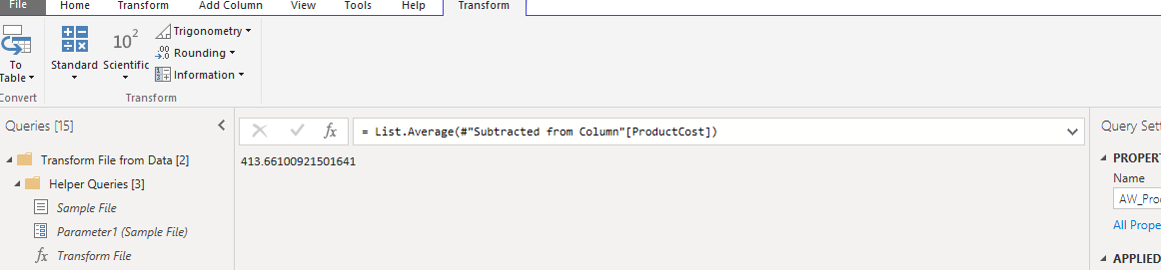

**Number of Distinct Product Colors:**

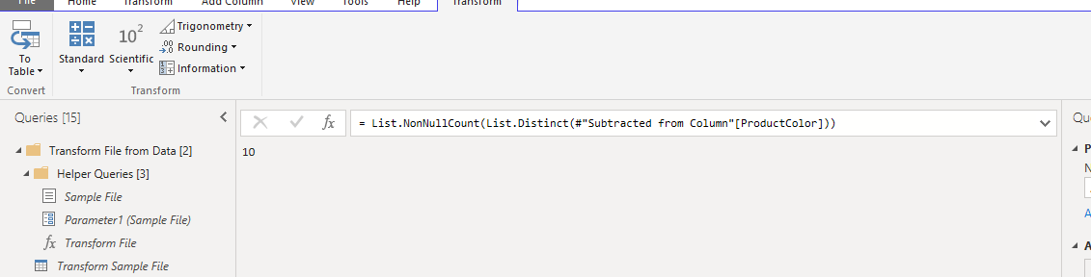

**Number of Distinct Customer names:**

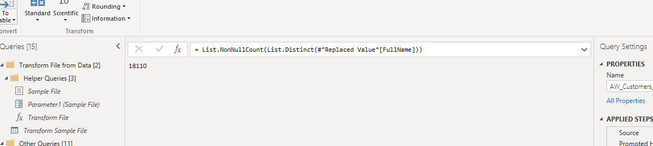

**Maximum Annual Income Customer:**

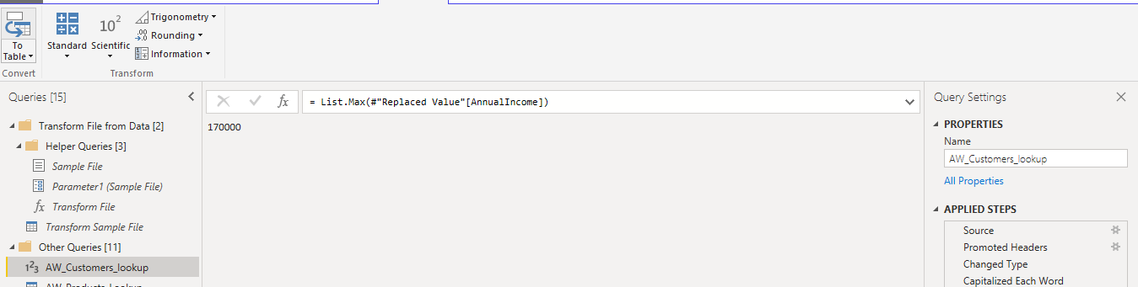

**Count of Order Numbers:**

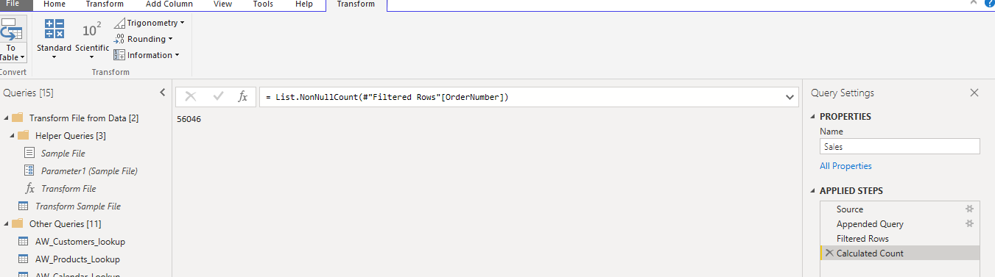

**Count of Distinct Order Numbers:**

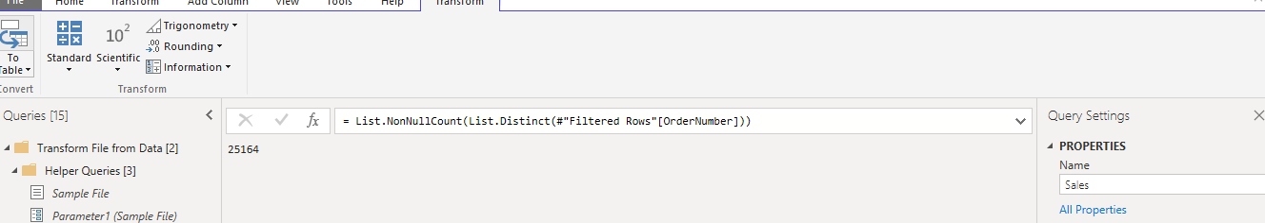

**Add a new calculate column for the year of birth (named “Birth Year”),based on birth date:**

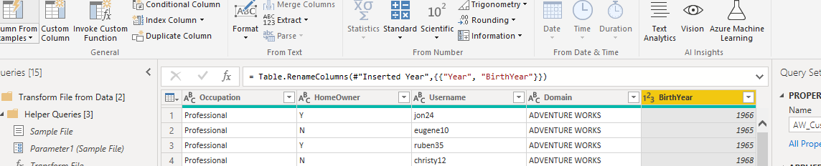

**Add a conditional column to categorize customer income(named “IncomeLeve”) based on the following criteria:**

